***For Your Health,***

***Julie Chicks, MD***

Intake History

|  |  |
| --- | --- |
| Name | Date of birth |
| Why are you coming to see Dr. Chicks? | |
|  | |
| **Current Medications, Dose, and Directions. Include over-the-counter & supplements.** Attach a list if you prefer. | |
|  | |
|  | |
|  | |
|  | |
|  | |
| **List medications you are allergic to** (or caused problems). **Describe the reaction.** Attach a list if you prefer. | |
|  | |
|  | |
| **List your food and/or environmental allergies. Describe the reaction.** Attach a list if you prefer. | |
|  | |
|  | |
| **SOCIAL HISTORY and HEALTH BEHAVIORS** | |
| Do you have an advanced directive? YES NO Do you want to information about advanced directives? YES NO | |
| Do you have a faith tradition? YES NO If yes, what faith | |
| What type of work do you do? Who is your employer? | |
| Last year of education completed _______ or degree earned- HS Diploma Technical AD BA/S Master Doctorate | |
| What are your hobbies? | |
| Marital Status- Never Living with partner Married Divorced Widowed Remarried | |
| Do you have children? NO YES List names & ages | |
| Who lives in your household? | |
| Do you restrict any foods/products from your diet? - | |
| Describe your typical diet- | |
| Do you exercise? NO YES Explain further- | |
| Do you routinely (100%) use: Helmets YES NO; Seat Belts YES NO | |
| Does your home have (as required by law) Smoke Detectors YES NO Carbon Monoxide Detectors YES NO | |
| Are there any guns or rifles in your home? NO YES If yes-are they stored in a locked cabinet? YES NO | |
| Do you use sunscreen? YES NO | |
| Do you use caffeine-containing products? YES NO If yes-describe the type, amount, and frequency of use. | |
|  | |
| Do/did you use nicotine products? Never Current Former If current/former- how many years of use, type, amount, frequency of use, (and when you quit). | |
| Do or have you used alcohol? Never Current Former If you do or have-describe the type, amount, and frequency of alcohol use (and when you quit). | |
| Are you or others concerned about your alcohol use? YES NO | |
| Do you get upset if anyone says you drink too much? YES NO | |
| Have you ever tried to cut back but it didn’t last? YES NO | |
| Do you have a “hair of the dog” sometimes because of not feeling well after drinking? YES NO | |
| Do or have you used marijuana, or marijuana like substances, or street drugs? Never Current Former  If current/former- how many years of use, type, amount, frequency of use, (and when you quit). | |
|  | |
| Do or have you used pain, anxiety, or sleeping pills not prescribed to you or more then prescribed?  Never Current Former If current/former- how many years of use, type, amount, frequency of use (and when you quit). | |
|  | |
|  | |
|  | |
|  | |
| Do you have tattoos, piercings or dermal implants? YES NO If yes-indicate location/type on the separate diagram. | |

**Name and Date of Birth**  **DOS Page 1 of 7** Physician initials _______

|  |  |  |  |  |  |  |  |
| --- | --- | --- | --- | --- | --- | --- | --- |
|  | | | | | | | |
|  | | | | | | | |
|  | | | | | | | |
|  | | | | | | | |
| Some of the following questions are very personal in nature. Remember ALL of your medical information shared  ­­ with and/or discussed with the doctor and the staff (at any time) is always held in the strictest confidence. | | | | | | | |
| How do you identify your gender/sexuality?  Female Male Transgender Heterosexual Gay Lesbian Bisexual Transsexual Asexual Not Sure | | | | | | | |
| In your lifetime, how many partners have you had? Zero One If more than 1, how many? (estimate if not sure) | | | | | | | |
| Are you currently sexually active? YES NO If yes, is the relationship monogamous? YES NO | | | | | | | |
| Have you been bullied or abused emotionally, and/or physically by a family member or someone else? YES NO | | | | | | | |
| Do you feel safe from verbal, emotional and/or physical abuse currently? YES NO | | | | | | | |
| Have you ever been sexually assaulted or molested? YES NO If you feel comfortable, explain more about your answers. | | | | | | | |
|  | | | | | | | |
|  | | | | | | | |
|  | | | | | | | |
|  | | | | | | | |
| **VACCINATIONS** | | | | | | | |
| Circle the vaccines you have received and list the approximate date. | | | | | | | |
| MMR |  | HPV |  | Influenza |  | Pneumovax 23 |  |
| Td/ Tdap |  | Hepatitis B |  | Shingles (Zoster) |  | Prevnar 13 |  |
| Chicken Pox |  | Hepatitis A |  | Meningitis |  |  |  |

|  |  |  |
| --- | --- | --- |
| **REVIEW OF SYSTEMS** | | |
| Have you recently developed, or been experiencing increased difficulty related to any of the symptoms listed below? If yes, circle and provide more details. | | |
| **General Health:** | | **Eyes, Ears, Nose, Throat, and Mouth cont.** |
| weight problems/change | | hearing loss |
| appetite change | | ringing in the ears |
| sleep problems/change | | poor sense of smell/taste |
| fatigue | | bleeding from nose |
| other concerns about health **What?** | | sinus pain or drainage |
|  | | sore throat |
| **Skin:** | | dental problems |
| itching | | sores in mouth |
| yellow skin or eyes | | other concerns **What?** |
| new or changing moles | |  |
| moles of unusual color or shape | | **Heart and Lungs:** |
| patches/areas of rough skin | | chest pain/discomfort |
| sweating | | rapid heartbeat for no reason |
| changes of skin nails or hair | | shortness of breath |
| change in voice | | “charley horses” in legs while walking |
| sores which don’t heal | | decreased or poor ability to exercise |
| skin infections | | becoming short of breath while lying down |
| hives | | waking up short of breath |
| other concerns **What?** | | cough with or without sputum |
|  | | blood in sputum |
| **Eyes, Ears, Nose, Throat, and Mouth:** | | wheezing or tightness in chest |
| neck pain | | snoring |
| eye pain | | fainting |
| ear pain/pressure | | other concerns **What?** |
| abnormal vision | |  |
|  | |  |
| **Name and Date of Birth DOS Page 2 of 7** Physician initials _______ | | |
|  | | |
|  | | |
|  | | |
|  | | |
|  | | |
| **Esophagus, Stomach, Intestines:** | | **Genital and Urinary Systems cont:** |
| problems swallowing | | blood or Coca-Cola colored urine |
| feeling as if food gets stuck | | vaginal discharge/odor/itch |
| heartburn | | uncomfortable or painful intercourse |
| sour taste in mouth | | discharge from penis |
| bad breath | | rash or sores on genitals |
| food coming up in your throat | | problems with orgasm |
| nausea or vomiting | | erectile dysfunction |
| abdominal pain/cramps | | lump in breast(s) or testicle(s) |
| diarrhea and/or constipation | | irregular menstrual periods |
| bloody, mahogany, black, or mucousy stools | | last period (mm/dd/yy) |
| painful bowel movements | | average days between periods (1st day to 1st  day) |
| other concerns **What?** | | describe flow (# of days, heavy days, etc.) |
|  | | pain before and/or during period |
| **Muscles, Joints, and Bones:** | | other concerns **What?** |
| swelling of legs/feet | |  |
| muscle aches/tenderness | | **Endocrine System:** |
| joint pain | | very hungry |
| lumps on bones or joints | | very thirsty |
| bone pain | | very frequent urination |
| joint swelling | | lump in front of neck |
| red or warm joints | | pain in front of neck |
| pain in back of heel | | hot flashes |
| pain in bottom of foot | | infertility |
| poor flexibility | | other concerns **What?** |
| changes in color of fingers | |  |
| other concerns **What?** | | **Immune System:** |
|  | | frequent infections |
| **Neurological System:** | | unusual lumps/bumps under skin |
| headaches | | unexplained fevers |
| problems driving at night | | other concerns **What?** |
| weakness in an area(s) of body or limb | |  |
| numbness in an area(s) of body or limb | | **Mental Health:** |
| pins and needles sensations | | anxiety or panic attack |
| difficulty speaking intermittent or otherwise | | repetitive thoughts or repetitive actions |
| dizzy or lightheaded | | racing thoughts |
| twitches | | flashbacks |
| tremors | | difficulty with concentration |
| balance problems or falls | | little interest in sex |
| problems with walking | | little interest in being with or around people |
| concerns about memory | | irritability |
| other concerns **What?** | | depression |
|  | | mood swings |
| **Genital and Urinary Systems:** | | feeling sad or tearful |
| leakage or urine or stool | | feeling it wouldn’t matter (to you) if you died |
| painful and/or frequent urination | | feeling as if life is not worth living |
| having to urinate urgently | | thinking of harming yourself / harming someone else |
| delay or weakness of stream | | other concerns **What?** |
|  | |  |
| **Name and Date of Birth** | | **DOS Page 3 of 7** Physician initials _______ |
|  |  | |
|  |  | |
|  |  | |
|  |  | |

|  |
| --- |
| **SURGICAL/PROCEDURAL and HOSPITALIZATION HISTORY**  Attach a list if you prefer. |
| Include approximate date, which surgery(ies) or procedure(s), and the name of physician(s) or facility(ies). |
|  |
|  |
|  |
|  |
|  |
|  |

|  |
| --- |
| **FAMILY MEDICAL HISTORY**  Attach a list if you prefer. |
| Are all of your biologic Grandparents, Parents, Aunts, Uncles, Siblings, and Children still living? If not, explain who has passed, at what age and why (as far as you know). |
|  |
|  |
|  |
|  |

|  |  |  |  |  |  |  |  |  |
| --- | --- | --- | --- | --- | --- | --- | --- | --- |
| **PERSONAL MEDICAL HISTORY AND FAMILY MEDICAL HISTORY** Attach a list if you prefer.  **Check the PH box if you have or have had the condition. Check the FH box if someone in your family has or has had the problem.** | | | | | | | | |
| PH | FH | Condition/Issue | Date of Onset (only for you) | PH | | FH | Condition/Issue | Date of Onset (only for you) |
|  |  | Environmental Allergies |  |  | |  | Diabetic Eye Disease |  |
|  |  | Hives |  |  | |  | Glaucoma |  |
|  |  | Overweight or Obese |  |  | |  | Cataract |  |
|  |  | Organ transplant |  |  | |  | Near or Far Sighted |  |
|  |  | Congenital/Birth Defects |  |  | |  | Other Eye/Ear Disorder |  |
|  | | **What?** | |  | | | **What?** | |
|  |  | Eczema |  |  | |  | Mouth/Dental Problems |  |
|  |  | Psoriasis |  |  | | | **What?** | |
|  |  | History of Blistering (2nd  degree) Sunburn |  |  | |  | Head Trauma/Injury |  |
|  | | | **What?** | |
|  |  | Acne |  |  | |  | Anemia |  |
|  |  | Skin Infections |  |  | |  | Bleeding Disorder |  |
|  |  | Cellulitis |  |  | |  | Factor 5 Leiden |  |
|  |  | Actinic Keratosis |  |  | |  | Clots in Legs or Lungs |  |
|  |  | Ulcers of Feet and/or Legs |  |  | |  | Blood Transfusion |  |
|  |  | Other Skin Disorder |  |  | |  | Other Blood Disorder |  |
|  | | **What?** | |  | | | **What?** | |
|  |  | Nasal polyps |  |  | |  | High Cholesterol |  |
|  |  | Sinusitis |  |  | |  | Low or High LDL circle one |  |
|  |  | Other Nose/Sinus Disorder |  |  | |  | Low or High HDL circle one |  |
|  | | **What?** | |  | |  | High Triglycerides |  |
|  |  | Hearing loss |  |  | |  | Heart Attack/Stroke circle one |  |
|  |  | Wax in Ear Canals |  |  | |  | Coronary Artery Disease |  |
|  |  | Ear Infections |  |  | |  | Carotid Artery Disease |  |
|  |  | Tinnitus (Ringing) |  |  | |  | Peripheral Artery Disease |  |
|  |  | Meniere’s Disease |  |  | |  | Abnormal Heart Rhythm |  |
|  |  | Macular Degeneration |  |  | |  | Swelling of Legs/Feet |  |
| **Name and Date of Birth** | | | | | **DOS Page 4 of 7** Physician initials _______ | | | |
|  | | | | |  | | | |
|  | | | | |  | | | |
|  | | | | |  | | | |
|  | | | | |  | | | |
|  | | | | |  | | | |
| **PERSONAL MEDICAL HISTORY AND FAMILY MEDICAL HISTORY (cont.)** Attach a list if you prefer.  **Check the PH box if you have or have had the condition. Check the FH box if someone in your family has or has had the problem.** | | | | | | | | |
| PH | FH | Condition/Issue | Date of Onset (only for you) | PH | | FH | Condition/Issue | Date of Onset (only for you) |
|  |  | Heart Valve Problem |  |  | |  | Tubal Pregnancy |  |
|  |  | Heart Murmur |  |  | |  | Pregnancy Loss Which trimester? |  |
|  |  | Congestive Heart Failure |  |  | |  | Pregnancy Problems |  |
|  |  | Congenital Heart Disease |  |  | | | **What?** | |
|  |  | Aortic Aneurysm |  |  | |  | Infertility |  |
|  |  | Erectile Dysfunction |  |  | |  | Other Reproductive Tract  Disorder |  |
|  |  | Other Heart/Vascular  Disorder |  |
|  | | | **What?** | |
|  | | **What?** | |  | |  | Osteoarthritis/DJD |  |
|  |  | Asthma |  |  | | | Where? | |
|  |  | Exercise Induced Asthma |  |  | |  | Joint Surgery |  |
|  |  | Reactive Airway Disease |  |  | | | Which? | |
|  |  | Emphysema/COPD |  |  | |  | Tendonitis |  |
|  |  | Other Respiratory  Disorder |  |  | | | Where? | |
|  | |  | Bursitis |  |
|  | | **What?** | |  | | | Where? | |
|  |  | Obstructive Sleep Apnea |  |  | |  | Sciatica |  |
|  |  | Narcolepsy |  |  | |  | Plantar Fasciitis |  |
|  |  | Other Sleep Disorder |  |  | |  | Osgood-Schlatter Disease |  |
|  | | **What?** | |  | |  | Thrombophlebitis |  |
|  |  | GERD |  |  | |  | Varicose Veins |  |
|  |  | Ulcer |  |  | |  | Other Muscle/Joint  Disorder |  |
|  |  | Irritable Bowel Syndrome |  |
|  |  | Crohn’s Disease |  |  | | | **What?** | |
|  |  | Ulcerative Colitis |  |  | |  | Carpal Tunnel Syndrome |  |
|  |  | Hepatitis A or B |  |  | |  | Fibromyalgia |  |
|  |  | Hepatitis C non-carrier |  |  | |  | Tremor |  |
|  |  | Hepatitis C chronic carrier |  |  | |  | Benign Positional Vertigo |  |
|  |  | Hemochromatosis |  |  | |  | Multiple Sclerosis |  |
|  |  | Pancreatitis |  |  | |  | Parkinson’s Disease |  |
|  |  | Abnormal Liver Tests |  |  | |  | Peripheral Neuropathy |  |
|  |  | Other Digestive Disorder |  |  | |  | Diabetic Neuropathy |  |
|  | | **What?** | |  | |  | Seizure Disorder |  |
|  |  | Urinary Incontinence |  |  | |  | Dementia |  |
|  |  | Bladder Infections |  |  | |  | Alzheimer’s Disease |  |
|  |  | Frequent Urination |  |  | |  | Stroke/CVA |  |
|  |  |  |  |  | |  | Brain Aneurysm/Rupture |  |
|  |  | Overactive Bladder |  |  | |  | Other Neurological  Disorder |  |
|  |  | Kidney Stones |  |
|  |  | Diabetic Kidney Disease |  |  | | | **What?** | |
|  |  | Cystic Kidney Disease |  |  | |  | Attention Deficit Disorder |  |
|  |  | Other Urinary System  Disorder |  |  | |  | Bipolar I |  |
|  | |  | Bipolar II |  |
|  | | **What?** | |  | |  | Bipolar Type Disorder |  |
|  |  | Vaginal Infections |  |  | |  | Anxiety general, social, |  |
|  |  | Endometriosis |  |  | |  | Panic Attacks |  |
| **Name and Date of Birth** **DOS Page 5 of 7** Physician initials _______ | | | | | | | | |
|  | | | | | | | | |
|  | | | | | | | | |
|  | | | | | | | | |

|  |  |  |  |  |  |  |  |  |  |  |  |  |
| --- | --- | --- | --- | --- | --- | --- | --- | --- | --- | --- | --- | --- |
| **PERSONAL MEDICAL HISTORY AND FAMILY MEDICAL HISTORY (cont.)**  **Check the PH box if you have or have had the condition. Check the FH box if someone in your family has or has had the problem.** | | | | | | | | | | | | |
| PH | FH | Condition/Issue | | | Date of Onset (only for you) | PH | | FH | Condition/Issue | | | Date of Onset (only for you) |
|  |  | Depression | | |  |  | |  | Low Testosterone | | |  |
|  |  | Obsessive Compulsive  Disorder | | |  |  | |  | Other Endocrine Disorder | | |  |
|  | | | **What?** | | | |
|  |  | Personality Disorder  Disorder | | |  |  | |  | Chicken Pox | | |  |
|  | |  | Shingles (Zoster) | | |  |
|  |  | Post Traumatic Stress  Disorder | | |  |  | |  | Infectious Mononucleosis | | |  |
|  | |  | Lyme’s Disease | | |  |
|  |  | Bulimia | | |  |  | |  | Tuberculosis (TB) | | |  |
|  |  | Anorexia Nervosa | | |  |  | |  | Sexually Transmitted  Disease | | |  |
|  |  | Other Mental Health  Disorder | | |  |
|  | |  | HIV/AIDS | | |  |
|  | | **What?** | | | |  | |  | Other Infectious Disorder | | |  |
|  |  | Hypothyroidism (Hashimoto’s) | | |  |  | | | **What?** | | | |
|  |  | Hyperthyroidism (Grave’s) | | |  |  | |  | Obstructive Sleep Apnea | | |  |
|  |  | Hypercalcemia | | |  |  | |  | Narcolepsy | | |  |
|  |  | Rheumatoid Arthritis | | |  |  | |  | Other Sleep Disorder | | |  |
|  |  | Lupus | | |  |  | |  | **What?** | | | |
|  |  | Raynaud’s Syndrome | | |  |  | |  | Lung Cancer | | |  |
|  |  | Sjogren’s Syndrome | | |  |  | |  | Colon or Rectal Cancer | | |  |
|  |  | Other Autoimmune  Disorder | | |  |  | |  | Breast or Ovarian Cancer | | |  |
|  | |  | Cervical Cancer | | |  |
|  | | **What?** | | | |  | |  | Melanoma Skin Cancer | | |  |
|  |  | Pre-diabetes | | |  |  | |  | Testicular Cancer | | |  |
|  |  | Gestational Diabetes | | |  |  | |  | Prostate Cancer | | |  |
|  |  | Diabetes Type I | | |  |  | |  | Other Cancer | | |  |
|  |  | Diabetes Type II | | |  |  | | | **What type?** | | | |
|  |  | Gout | | |  |  | | |  | | | |
| **SCREENING TESTS – when was your last and/or first of the tests listed below?** (Approximately) | | | | | | | | | | | | |
| Test | | | Date | Test | | | Date | | | Test | Date | |
| Colonoscopy | | |  | Prostate test | | |  | | | Sugar |  | |
| Mammogram | | |  | Bone Density | | |  | | |  |  | |
| Pap Smear | | |  | Cholesterol | | |  | | |  |  | |
| **Is there anything else I should know about you? Is there any other topic you want to discuss?** | | | | | | | | | | | | |
| **Explain here-** | | | | | | | | | | | | |
|  | | | | | | | | | | | | |
|  | | | | | | | | | | | | |
|  | | | | | | | | | | | | |
|  | | | | | | | | | | | | |
|  | | | | | | | | | | | | |
|  | | | | | | | | | | | | |
|  | | | | | | | | | | | | |
|  | | | | | | | | | | | | |
|  | | | | | | | | | | | | |
|  | | | | | | | | | | | | |
| **Name and Date of Birth** | | | | | | | **DOS Page 6 of 7** Physician initials _______ | | | | | |

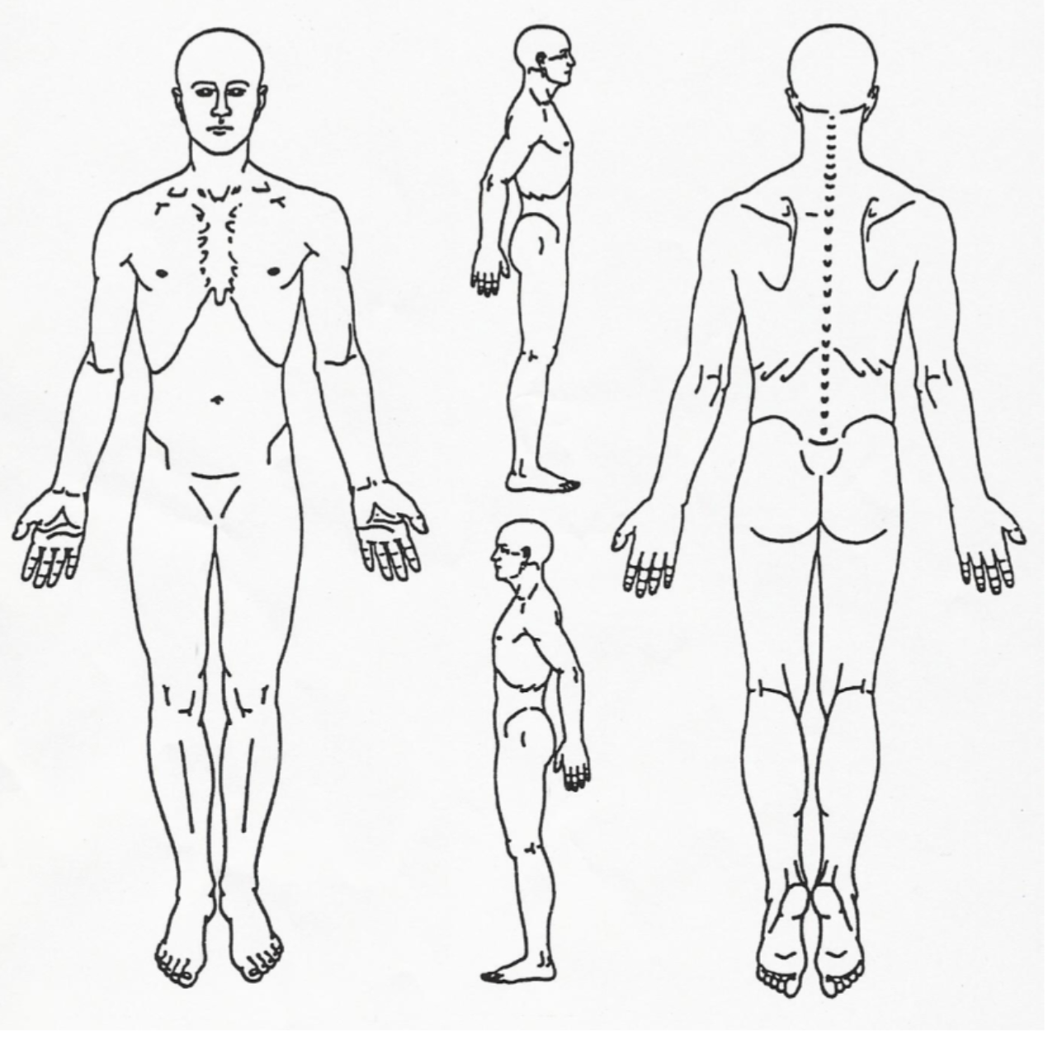

|  |  |  |  |  |  |
| --- | --- | --- | --- | --- | --- |
| Indicate the location of your piercings, tattoos and scars. Describe below. | | | | | |
|  |  | | | |  |
|  |  | | | |  |
|  |  | | | |  |
|  |  | | | |  |
|  |  | | | |  |
|  |  | | | |  |
|  |  | | | | |
|  |  | | | | |
| **Name and Date of Birth** |  |  |  | **DOS** | **Page 7 of 7** physician initials ____________ |